Faculty of Computing

CS-212: Object-Oriented Programming
Class: BESE-16B
Instructor: Dr. M. Daud Abdullah Asif

Assignment 1 – Semester Project Proposal

“PennyPoint: A Money-Spending Tracking App”
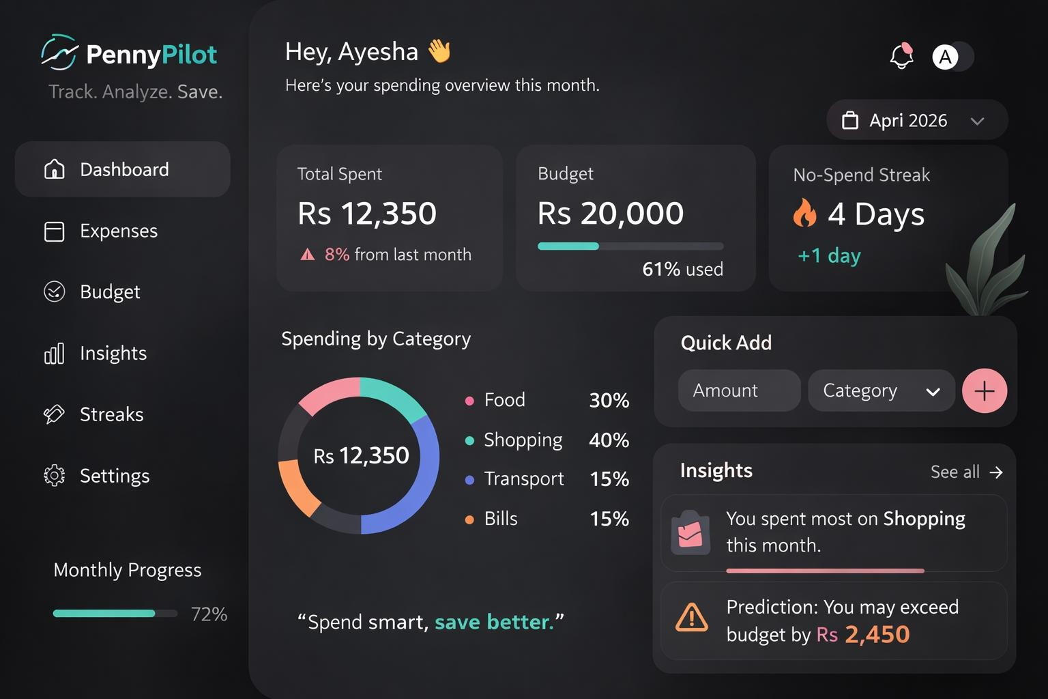
By: Maryam Ateeq (549392) and M. Shahmeer Shaheedi (565007)

About the Project and its Objectives
Managing one’s monthly or weekly budget is often seen as a tedious task, especially for students who have to manage expenses for their transport, food, leisurely activities, and (in some cases) even rent. Most people don’t keep a proper record of their expenses, which makes it hard to understand where their money is going and it’s difficult to keep track of the flow. Because of this, they often develop poor spending habits. Traditional methods such as writing expenses in a notebook are not very effective because it’s easy to lose those records by misplacing them.
To solve this problem, we're developing PennyPoint, an app that focuses on tracking the expenses of its users over a time interval and helps them budget and save their money as a result. The application will allow users to easily record their daily expenses and organize them into categories such as food, transport, shopping, and bills.
The main objective of the project is to not only help users classify their finances, but to also motivate them to abstain from wasting money on unnecessary things. The application will provide visual charts to help the user visualize what categories their spending fall in into and how to better optimize it to ensure maximum savings. It will also include features like budget prediction and a no-spend streak tracker to encourage better financial habits.

Scope, Features, and Functionality

PennyPoint, as it stands, is to have quite a few features to aid its users to the best of its potential. Currently, the proposed features are as follows:
- Expense Recording:
Users will be able to enter the amount of money they spend on the daily by entering details such as the amount, category, and date. This helps them see not only how much they spent their allowance, but also where they’ve spent it.
- Category Spending Chart:
The application will display a visual representation of spending using a pie chart. This helps users quickly understand how their money is distributed among different categories e.g was the most money in the month of February spent on apparel, transport, or food?
- Smart Budget Prediction:
Users can set a monthly budget, and the system will track their average daily spending and predict if/when they will start to exceed their monthly budget.
- No-Spend Streak Tracker:
This feature encourages better spending tracker as user will be more motivated to spend less money. Obviously basic needs such as transport or rent doesn’t break the streak as they are unavoidable expenses, but things like going out to bowl or going to a party definitely break it.
These features will undergo further checks, and the decision on whether or not to include a certain feature will depend on the practicality and ease of implementation (with deadlines in mind).

Technology and Tools Involved

For this project, we shall use Java as the programming language. This decision is backed by the fact that Java is a great tool to handle conditional logic for features like unusual spending detectors and no-spend streaks. Moreover, the modular design in Java makes it easier to add updates. For example, if we ever have to create a feature in the future that allows Under-18 people to create an account, we could simply create one as a subclass of “USER”, without having to rewrite the entire app. It can also multitask, adding data to your weekly spending recap as you enter your. Moreover, it is a high-level language, making it easier to read, and the modularity would make it easier to track the changes.
As far as UI is concerned, we plan on using JavaFX Charts to display no-spend streaks, spending percentage pie charts etc. We also look to enhance the overall user experience by creating an app whose features are easy to track and use.
Coming to data storing and handling, we currently plan on using File Handling for the first version of our project (the prototype) because it’s more accessible coding-wise and is easier to execute. For future prospects, though, we look to make use of more effective databases like SQL for storing and manipulating data of a large number of users (data such as income, spending, taxes, assets, investments, age, name, etc.).

Team Members

- Muhammad Shahmeer Shaheedi: He is mainly responsible for the app’s interface. He will look to make the app easily trackable and user-friendly.
- Maryam Ateeq: She is mainly responsible for the app’s logic. She will try to make the code as modular and readable as possible.
Apart from that, the members may explore each other’s roles as well to gain exposure and practice for newer concepts, so that they have experience in both UI designing and back-end coding.

Deliverables

- A file that can run the app with all its functionalities and UI features included.
- A report that tracks the progress of the project.
- A final report covering the features, functionalities, objectives, and execution of the project/app.
- A GitHub collab repository where one can track the history of the code and report(s).

